**Project Design Phase-I**

**Solution Architecture**

|  |  |
| --- | --- |
| Date | 20 September 2022 |
| Team ID | PNT2022TMID24304 |
| Project Name | Project - Nutrition assistant Application |
| Maximum Marks | 4 Marks |

**Solution Architecture Diagram:**

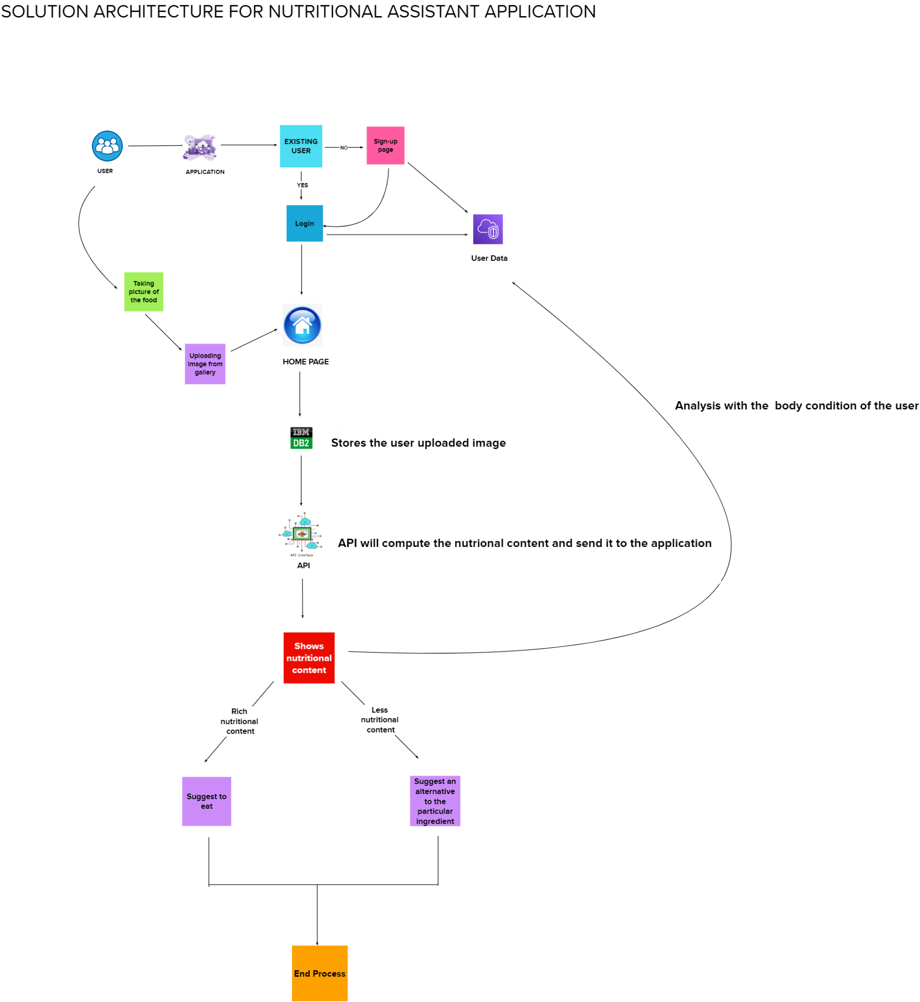

**Reference:** [**https://aws.amazon.com/blogs/industries/voice-applications-in-clinical-research-powered-by-ai-on-aws-part-1-architecture-and-design-considerations/**](https://aws.amazon.com/blogs/industries/voice-applications-in-clinical-research-powered-by-ai-on-aws-part-1-architecture-and-design-considerations/)